ON&ON Masala Kawah (10 Tea Bags)MRP₹209.00

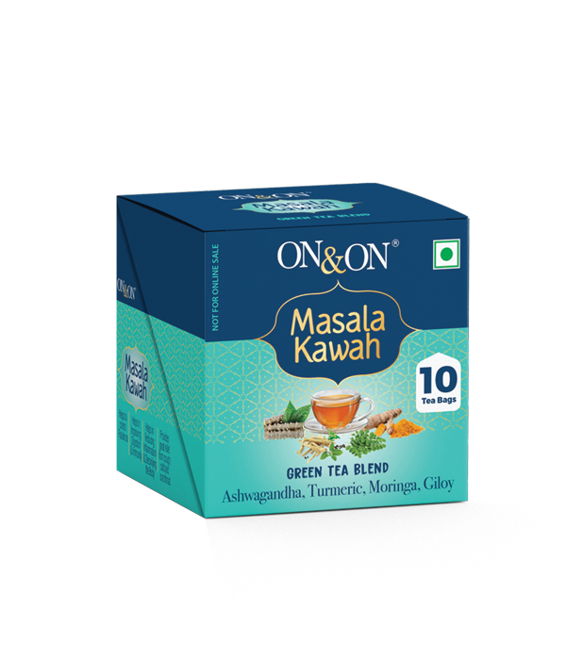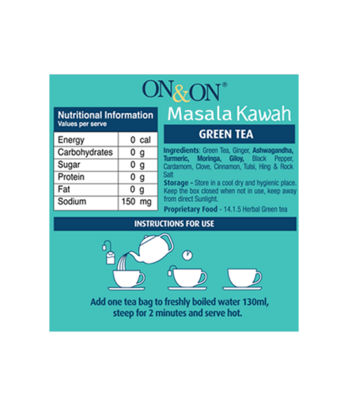

Product Description:
A blend of, over a dozen different spices and herbs with multiple health benefits. This taste is perfected on basis of the much appreciated Kadha/Kawah which is popularly consumed in North & Western India.
Net Qty:10 tea bags

Instructions for use:Add one tea bag to freshly boiled water 130ml, steep for 2 minutes and serve hot.
Ingredients:Green Tea, Ginger, Ashwagandha, Turmeric, Moringa, Giloy, Black Pepper, Cardamom, Clove, Cinnamon, Tulsi, Hing & Rock Salt.

Storage:Store in a cool dry and hygienic place. Keep the box closed when not in use. keep away from direct Sunlight.

Manufactured by:Crystal Tea India Pvt. Ltd. Site No 12, Jawahar Nagar, TVS Nagar Road, Kavundampalayam, Coimbatore-641030, Tamil Nadu, India, Fssai Lic.No: 12417003002432.

Marketed by:Mi Lifestyle Marketing Global Private Limited, No.25, G.N. Chetty Road, T. Nagar, Chennai-600017, Tamil Nadu. Fssai Lic.No: 10016042002407.

Shelf life:Use before 24 months from the date of manufacture.

Additional Information:ON&ON Masala Kawah Green Tea Blend is a flavorful and aromatic herbal blend with a dozen of different spices and herbs with many health benefits. The taste of the blend is perfected on the basis of the much appreciated Kawah that is popularly consumed in North & Western India.
Used for: General wellbeing of an individual.
Benefits: General wellbeing of an individual.
Disclaimers: Product is required to be stored out of reach of chILDREN

Aahar Chilli Powder (500g) MRP
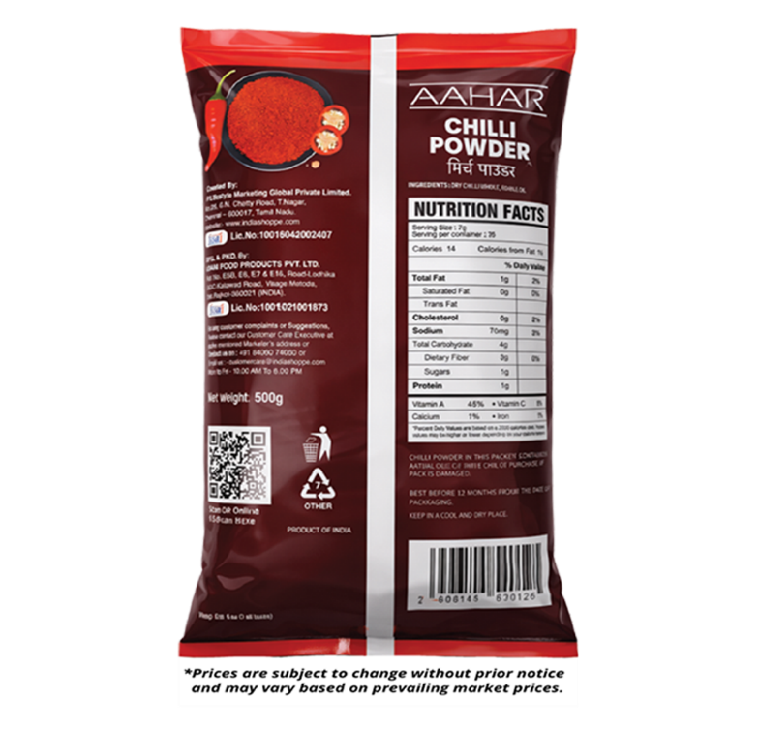
₹370.00

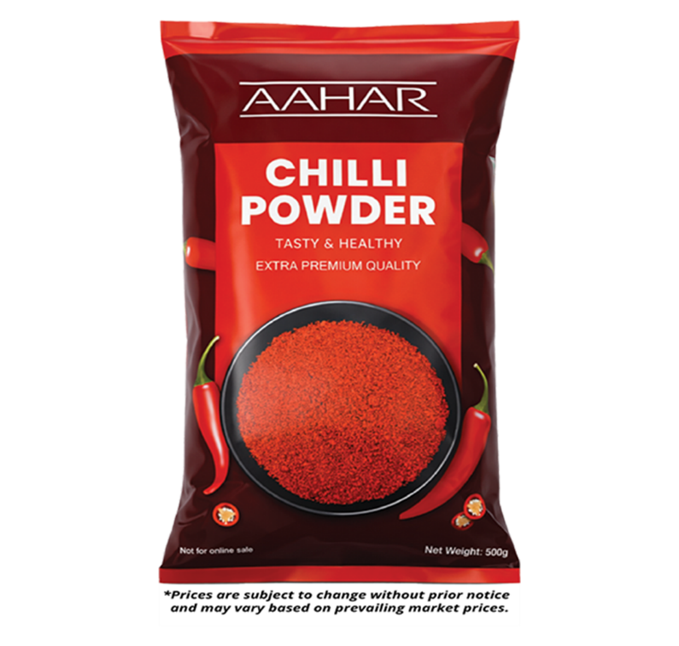

Product description:
AAHAR Chilli Powder is dedicated to purity and authenticity, made from hand-selected, stemless chillies sourced directly from the finest chilli-growing regions of India. Processed in a state-of-the-art facility using advanced air-wash technology, it is micro-biologically tested to ensure superior quality and safety. Our chilli powder delivers the perfect balance of vibrant colour, natural aroma, and ideal heat, enhancing the flavour of every recipe.

Net Weight:
500g

Directions of use:
Use in daily cooking as per taste preferences. Suitable for all food preparations.

Ingredients: Dry Chilli Whole, Edible Oil
Storage: Store in a cool and dry place away from sunlight and moisture. Keep the pack tightly sealed to retain freshness and aroma.

Manufactured by: ADANI FOOD PRODUCTS PVT. LTD., Plot No. E5B, E6, E7 & E16, Road-Lodhika, GIDC Kalawad Road, Village Metoda, (INDIA) Dist.Rajkot-360021. Lic.No:10015021001873

Marketed by: Mi Lifestyle Marketing Global Private Limited, No.25, G.N. Chetty Road, T. Nagar, Chennai - 600017, Tamil Nadu.
Shelf life: Best before 12 months from the date of packaging.

Additional information: Additional information:
Crafted with care to deliver authentic flavour, natural colour, and consistent quality in every spoonful.
Used for:Daily cooking, curries, snacks, chutneys, seasonings and other food preparations.
Benefits:AAHAR Chilli Powder adds natural vibrant colour, rich aroma, and balanced spiciness to everyday meals. It contains natural antioxidants and nutrients like Vitamin A, Vitamin C, and iron that may help support immunity and overall wellness. It also enhances digestion by stimulating appetite and flavour naturally.

Aahar Coriander Powder (500g)
MRP
₹245.00

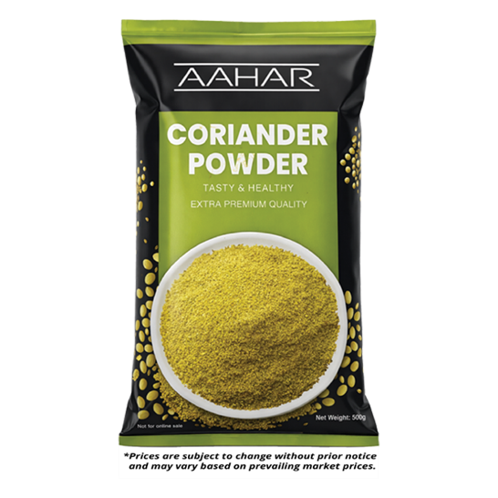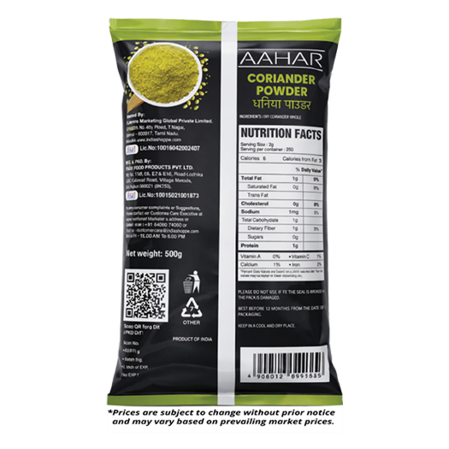

Product description:
AAHAR Coriander Powder is made from premium-quality whole dried coriander seeds, freshly ground to preserve natural aroma, flavour, and nutritional value.

Net Weight: 500g
Directions of use: Use in daily cooking as per taste preferences. Suitable for all food preparations.

Ingredients: Dry Coriander Whole.

Storage: Store in a cool and dry place away from sunlight and moisture. Keep the pack tightly sealed to retain freshness and aroma.

Manufactured by: ADANI FOOD PRODUCTS PVT. LTD., Plot No. E5B, E6, E7 & E16, Road-Lodhika, GIDC Kalawad Road, Village Metoda, (INDIA) Dist.Rajkot-360021 Lic.No:10015021001873.

Marketed by: Mi Lifestyle Marketing Global Private Limited, No.25, G.N. Chetty Road, T. Nagar, Chennai - 600017, Tamil Nadu.

Shelf life: Best before 12 months from the date of packaging.

Additional information: Freshly ground coriander seeds for superior aroma and purity.
Used for: Daily cooking, curries, snacks, chutneys, seasonings and other food preparations.
Benefits: Coriander is traditionally regarded for its digestive-supporting properties and soothing flavour. It may help improve metabolism and support gut wellness due to its natural dietary fibre and beneficial plant compounds. It's refreshing aroma elevates the taste and fragrance of every dish.
Aahar Tealite 500 Gms₹420.00

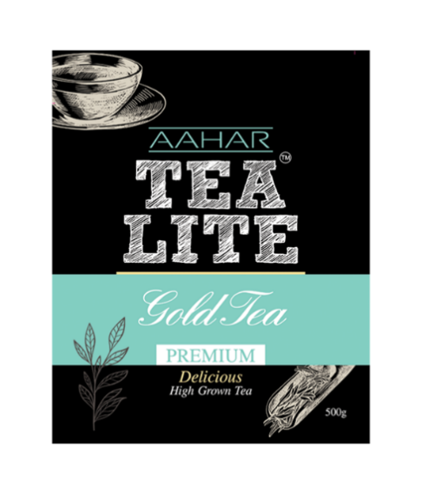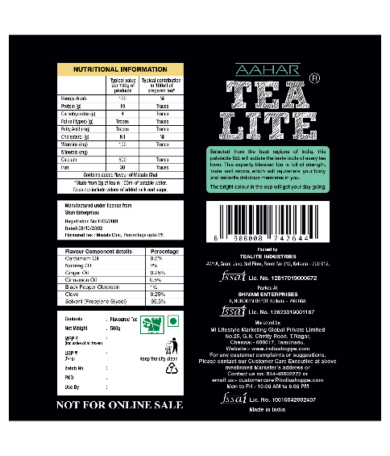

Product Description:
Wake up to a morning filled with freshness, warmth, and energy with Aahar Tea Lite. This premium tea offers an authentic and delightful experience with every sip. Aahar Tea Lite is sourced from the finest tea regions. Enjoy the richness and purity that each cup of Aahar Tea Lite brings from the renowned plains.
Net Weight: 500gms
Storage InstructionsStore in a cool, dry place away from direct sunlight. Keep the container tightly closed when not in use to maintain freshness.

- Used for: Providing a refreshing start to the day
- Offering a comforting and warming sensation
- Enjoying high-quality, authentic tea

- Benefits: Freshness: Starts your day with a refreshing and invigorating taste.
- Warmth: Provides a comforting and warming sensation with every sip.
- High Quality: Made from first-class, adulteration-free tea leaves.

- Uniqueness: Sourced from renowned tea regions
- Free from adulteration
- High-quality, first-class tea leaves

- Usage: Boil Water: Bring fresh water to a boil.
- Add Tea: 1 teaspoon of Tea Lite leaves into a cup.
- Pour Water: Pour the boiling water over the tea bag or leaves.
- Steep: Allow the tea to steep for 3-5 minutes, depending on your desired strength.
- Enjoy: Remove the tea bag or strain the leaves, and enjoy your refreshing cup of Aahar Tea Lite. Add sweeteners or milk if desired.

- Results of using the product: A refreshing and invigorating start to the day
- A comforting and warming tea experience
- Enjoyment of high-quality, authentic tea

Aahar Himalayan Pink Salt (1kg)
MRP
₹120.00
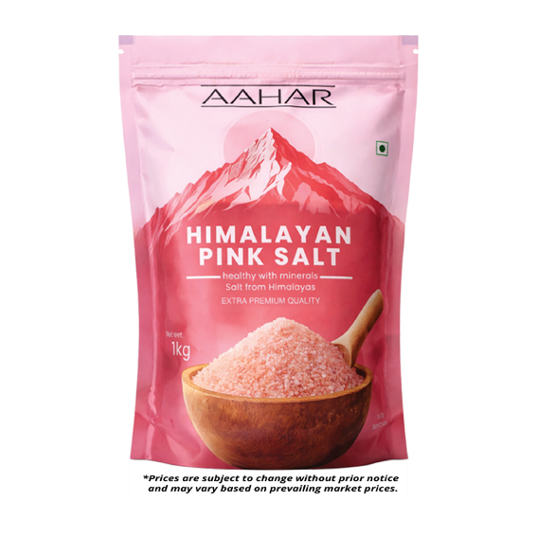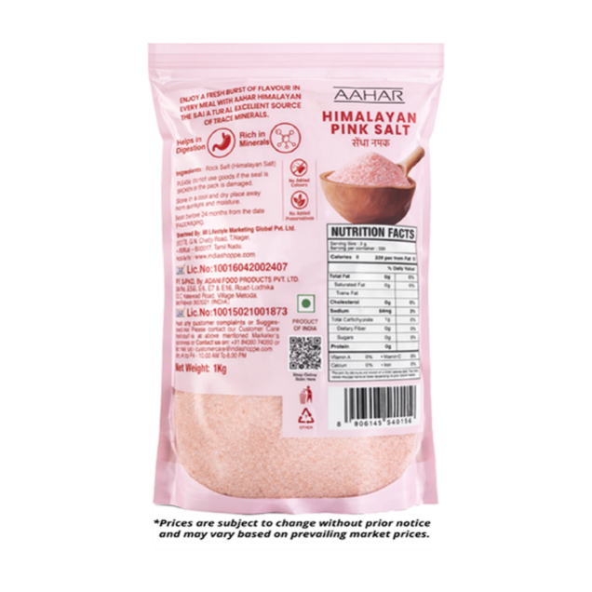

Product description:
AAHAR Himalayan Pink Salt, also known as Saindhava Lavana / Sindhav Namak, is a naturally occurring rock salt. Free from additives and chemical processing, this salt is valued for its purity, mild flavour, and therapeutic properties.
Net Weight: 1kg

Directions of use: Use in everyday cooking and seasoning as per taste requirements. Suitable for all food preparations, including fasting recipes.

Ingredients: Rock Salt (Himalayan Salt)

Storage: Store in a cool and dry place away from sunlight and moisture.

Manufactured by: ADANI FOOD PRODUCTS PVT. LTD., Plot No. E5B, E6, E7 & E16, Road-Lodhika, GIDC Kalawad Road, Village Metoda, (INDIA) Dist.Rajkot-360021 Lic.No:10015021001873

Marketed by: Mi Lifestyle Marketing Global Private Limited, No.25, G.N. Chetty Road, T. Nagar, Chennai - 600017, Tamil Nadu.

Shelf life: Best before 24 months from the date of packaging.

Additional Information:
Used for: Daily cooking and seasoning, Fasting and diet-friendly recipes, can be used for salt baths, soaks and DIY scrubs.
Benefits: Naturally rich in trace minerals that may support healthy digestion and overall wellness. Compared to regular white table salt, Himalayan Pink Salt's natural mineral balance may help support healthier blood pressure levels when consumed in moderation. Gentle on the stomach and suitable for fasting, enhancing food with a mild and natural flavour.

Aahar Turmeric Powder (500g) MRP
₹265.00

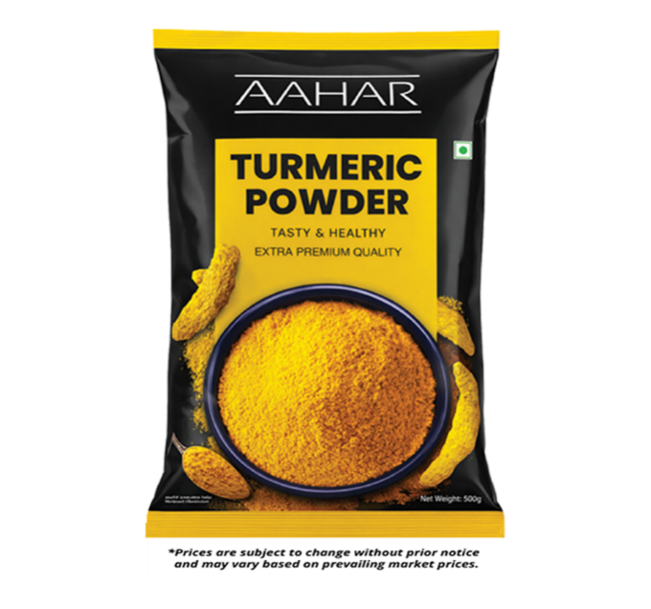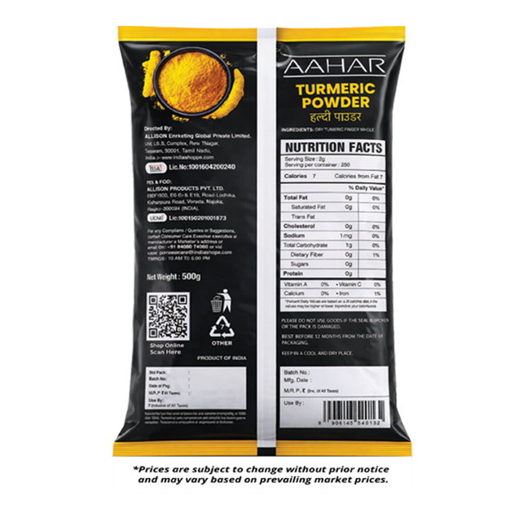

Product description:
AAHAR Turmeric Powder is made from high-quality turmeric, carefully cleaned, dried, and finely ground to preserve its natural golden colour and purity. Known for its traditional Ayurvedic value, turmeric is widely used in Indian cooking for flavour, colour, and wellness support.
Net Weight: 500g

Directions of use: Use in daily cooking as per taste preferences. Suitable for all food preparations.

Ingredients: Dry Turmeric Finger Whole

Storage: Store in a cool and dry place away from sunlight and moisture. Keep the pack tightly sealed to retain freshness and aroma.

Manufactured by: ADANI FOOD PRODUCTS PVT. LTD., Plot No. E5B, E6, E7 & E16, Road-Lodhika, GIDC Kalawad Road, Village Metoda, (INDIA) Dist.Rajkot-360021 Lic.No:10015021001873
Marketed by: Mi Lifestyle Marketing Global Private Limited, No.25, G.N. Chetty Road, T. Nagar, Chennai - 600017, Tamil Nadu.

Shelf life: Best before 12 months from the date of packaging.

Additional information: Finely ground from dried whole turmeric fingers for purity, colour, and natural potency.
Used for: Daily cooking and other food preparations.
Benefits: Turmeric is known for its natural antioxidant properties and may help support overall health and immunity. It is traditionally valued for supporting digestion, joint comfort, and natural healing. Its bright colour and warm flavour enhance the richness of everyday meals.

